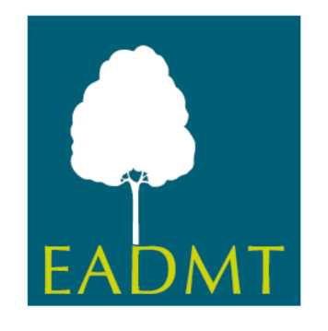
Requirements for application of
Associated Member

Country:

Year of Application:

To fulfill the requirements for the application of Associated Member status as a National DMT Association the following evidence is required in English:

 | date | notes
1.The Association has:

1.1 Statutes of the National Association

1.2 Rules of Procedures

2. Commitment to the aims of EADMT, payment of required fee’s, and some financial, or other, support for their national association’s official delegate towards EADMT business.

3. Commitment to follow EADMT Guidelines for implementation of Training Standards

It is suggested that Full Professional Members, Full Basic Professional Members and Associate Members will each strive to require DMT training programmes in their country to meet the adopted standards.

