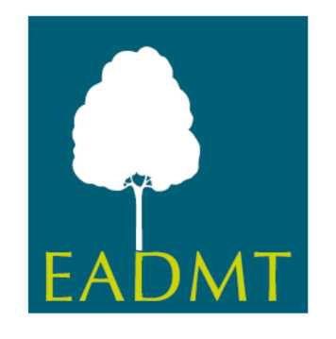
Requirements for application of
Basic Full Member

Country:

Year of Application:

To fulfill the requirements for the application of Basic Full member status as a national DMT association the following evidence is required:

 | see page / § | approved
1.The Association has:

1.1 Statutes of the National Association

1.2 Rules of Procedures

1.3 An Ethical Code of the National Association

1.4 Professional Development opportunities for DMT practitioners

2. Association’s minimum requirements for professional DMT practitioners include that the Association has established:

2.1. Minimum standards for DMT training:

2.1.1. Completion of DMT training programme

2.1.2 Minimum programme length is the equivalent of 2 years

2.1.3 Programme covers:
- DMT skills
- DMT theory
- Movement observation skills
- Introduction to research

2.2. DMT Internship (may extend beyond taught programme) includes:

2.2.1 DMT practice with clients

2.2.2. DMT practice with clients

2. 3 Personal therapy experience: (to be officially recommended or required by the national association)

3. Commitment to the aims of EADMT, payment of required fee/s, and some financial, or other, support for their national association’s official European delegate towards EADMT business.

