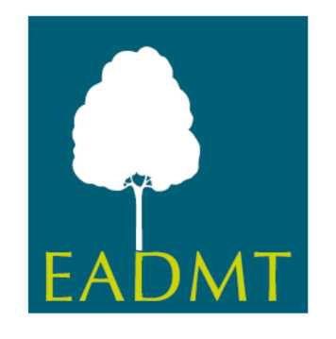
Requirements for the renewal of
Professional Full Membership

Country:
Peer Review Country:
Year of Renewal:

 | see document page / § | approved
1. The National Association has established:

  - Statutes

Parts of statutes to be translated:

- Headlines of the sections

- Aims of the Association

- Types of membership

1.2 Rules of Procedures

Parts of Rules of Procedure to be translated:

- Headlines of the sections

- Types of membership

1.3 Ethical Code for DMT practitioners

• Headlines of the sections to be translated

1.4 Continuous Professional Development and training for DMT practitioners:

141. How CPD is regulated - the number of hours required by association

1.4.2. How associations provide CPD opportunities for their members

2. Association minimum requirements for professional DMT practitioners include:

2.1. Training:

    - Adoption of new training standards completed

• documentation confirming the decision the new training standards (GA minutes, Rules of Procedures etc.)
    - Completion of a coherent DMT training programme (minimum Second Cycle / Masters level or equivalent)
    - Minimum programme length 2 years (min 120 ECTS)
    - Programme covers:

- DMT skills (e.g., reflective practice - movement & verbal; interpersonal dynamics; leading groups) (~ 18 ECTS)

- DMT theory (e.g., DMT history, Creativity, human movement development and development psychology; psycho-pathology; social & cultural contexts; group dynamics; mind/body somatic) (~18 ECTS)

- Movement observation skills (e.g., LBMS and other such tools; analysis system/s; movement profiling; assessment and goal setting) (12 ETCS = 96 -120 hrs.)

- Research skills (e.g., refining enquiry; collecting & critically analyzing evidence; presenting conclusions) (4 ECTS = 20-40 hrs.)

2.2 DMT Internship - 35 ECTS (min 875 hrs.)

    - DMT clinical practice/internship:

- 160 face to face hours DMT sessions (e.g., within psychiatry, education, social settings) and 715 hours professional duties (e.g., alongside other professionals, attending meetings, client reviews, writing records), within the internship.

- Minimum of two client populations, with experience in mental health settings where possible, Group and 1:1 experience where possible

2.2.2 Supervision - 10 ECTS (min 100 hrs.)

Recommendation that these hours include experience of both individual and group supervision.

2.3 Personal therapy:

- Minimum 100 hours is an official requirement by the national association to become a professional member or to practice DMT. 60 hours should be concurrent with programme

3. Association procedures & criteria for:

3.1 Registering professional practitioners who fulfill minimum EADMT requirements

3.2 Recognition or Accreditation of professional trainings based in the country (see 2. above)

3.3 Renewal of accredited training programs (implementing new TS criteria)

4. Commitment to the aims of EADMT, payment of required fee/s, and agreed financial support for the national association’s official European delegate to carry out EADMT business.

