How to submit a proposal on Easychair
- Lick on the submission link of EADMT conference :
https://easychair.org/conferences/?conf=eadmt22
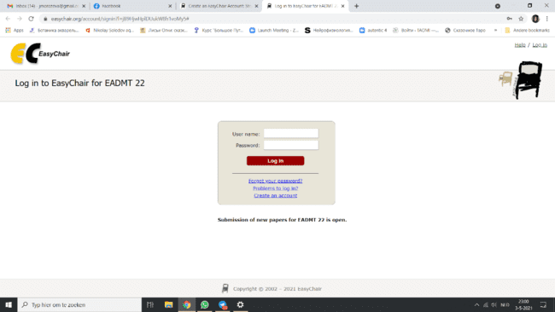
You get tot this screen. If you already have an account on EasyChair - login and the job is done! If you are using Easychair fort he first time, you need to create an account.

- New Account, The first is easy, read and confirm you are not robot.
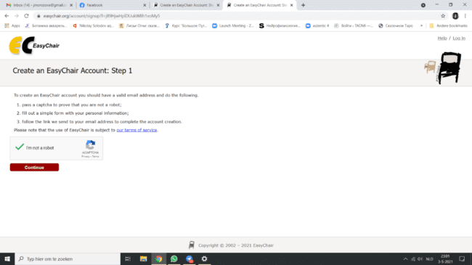
The second step is as easy as the first one: Fill in your name and email address. Submit, read the document
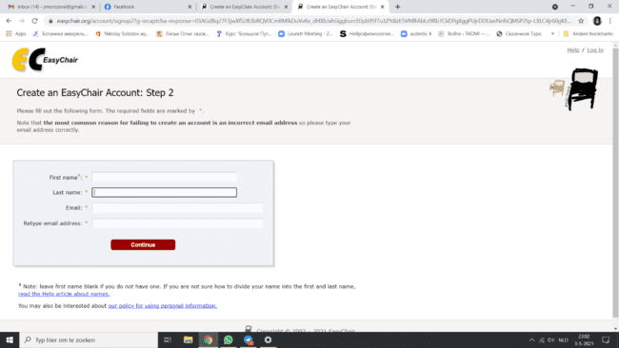
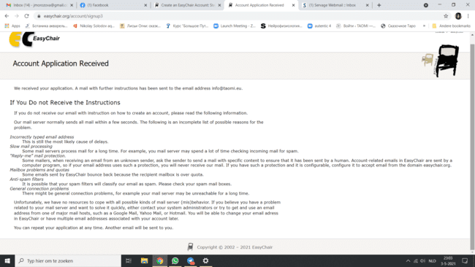

- Go to your mailbox. Click on the link there. NB! The link is temporary and has an expiration date.

- Back on Easychair you create your account and fill in the information required.
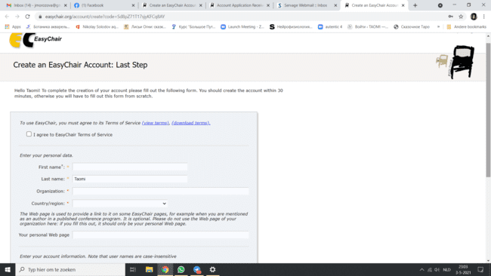

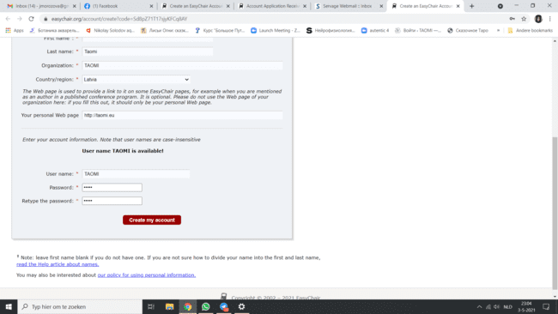

- The account is ready!
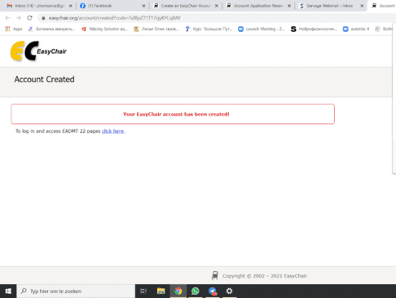

- Now you can submit your proposal! Please, read in advance the document “Guidelines” and prepare your proposal before yo entered into Easychair. Log in into Easychair:
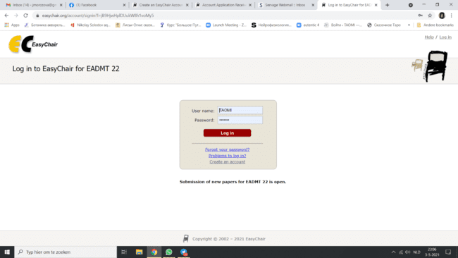

- When on submission page EADMT 22 click on the link “make a new submission”

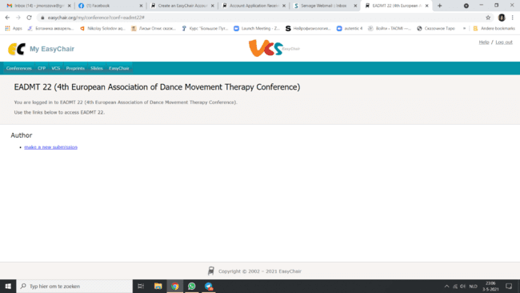

- Fill in the information about the authors, title and short summary of your proposal (150 words), keywords and all additional information required. Finally, upload the Word document of your proposal. Remember that this should be anonymous.

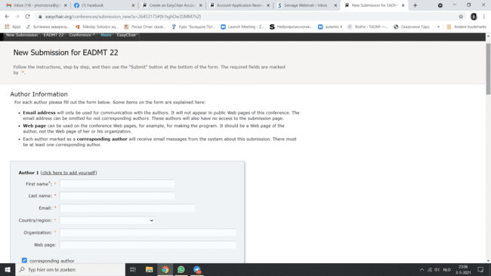

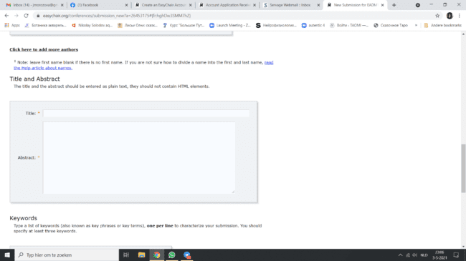

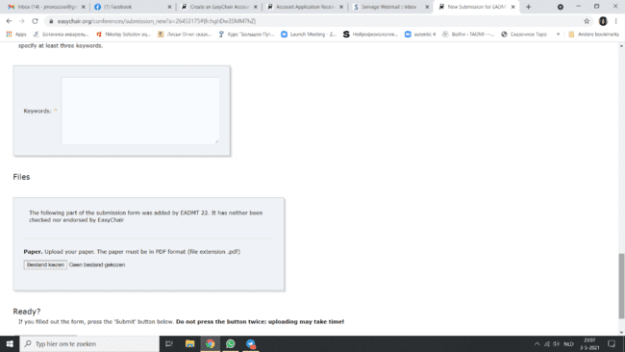

Et voila! Your proposal is submitted! You will get the confirmation from Easychair on your email-address.

