
Adda Paizi - TSC Coordinator is a Senior Registered Dance Movement Psychotherapist, Certified Supervisor (BPS), Creative Supervisor and also Supervisor on GADT’s 3-year DMT Training Program. Committee Member on Training Standards and Education of the GADT. Works as DMT Practitioner in the National Health Care System and as a Private Practitioner. She is a Certified Somatic Movement Practitioner, a Dance Educator and a Choreographer
DMT Training program attended: IDTIA- GADT Training Program in DMT (M.B. Leventhal DMT Training Model 1994-1997)
Academic titles and professional experience: Holds a BA in Philosophy and Dance. Has extensive training in psychoanalytic psychotherapy, relational psychoanalytic psychotherapy, and psychoanalytic psychosomatics. She is a Certified Supervisor (BPS), and creative supervisor. She is a Certified Pilates Practitioner with extensive training in the field of Somatics.
Working for 23 years as DMT practitioner in National Health Care Centers and Institutions with various populations: youth and adults with developmental disorders, youth and adults with mental-psychiatric disorders, adults with cancer and other psychosomatic disorders, oncological nurses and mental health practitioners on burn-out issues. Also works as a private practitioner.
Research interests: cooperation with National and Kapodistrian University of Athens (Psychology Department) in graduate research study about DMT with cancer patients concerning her own Integrative Psychodynamic DMP Model for Cancer.

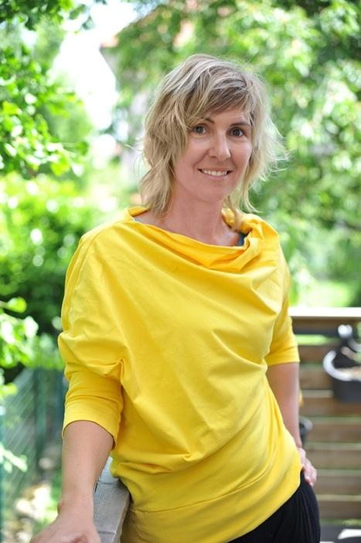
Vesna Jevšenak is a registered dance movement psychotherapist (R-PGP, ZPGPS/EADMT) and facilitator of The Body Mind Approach® for People with Medically Unexplained Symptoms in Slovenia. Before specialising in Arts Therapies – Dance and Movement at the University of Ljubljana in 2014, she first graduated in Law at the same university in 2004. She has a lifelong background in expressive, Oriental and Indian dance and over two decades of experience as a dance teacher. She offers individual and group dance movement psychotherapy for adults and leads dance–movement workshops for preschool children in both regular and developmental kindergarten settings.


Noémie Cattez is a Dance Movement Psychotherapist (Goldsmiths University of London graduate) with a decade of experience working across the UK and Ireland. Originally from France, Noémie has lived abroad for nearly 20 years, giving her a unique cross-cultural perspective on both therapeutic work and life. Currently based in Donegal, Ireland, she works full time with survivors of sexual violence. Noémie is also serving on the executive council for the Irish Association of Creative Arts Therapists (IACAT) as secretary since 2018. During that time she has played a key role in establishing a variety of systems and continues to contribute to the implementation of critical advancements for the association, specifically with regards to training standards, statutory recognition, education about the creative arts therapies nationally and governance. As Irish delegate to EADMT and member of the Training Standards Committee since 2021, Noémie is passionate about strengthening the education standards for current and future Dance Movement Psychotherapists.

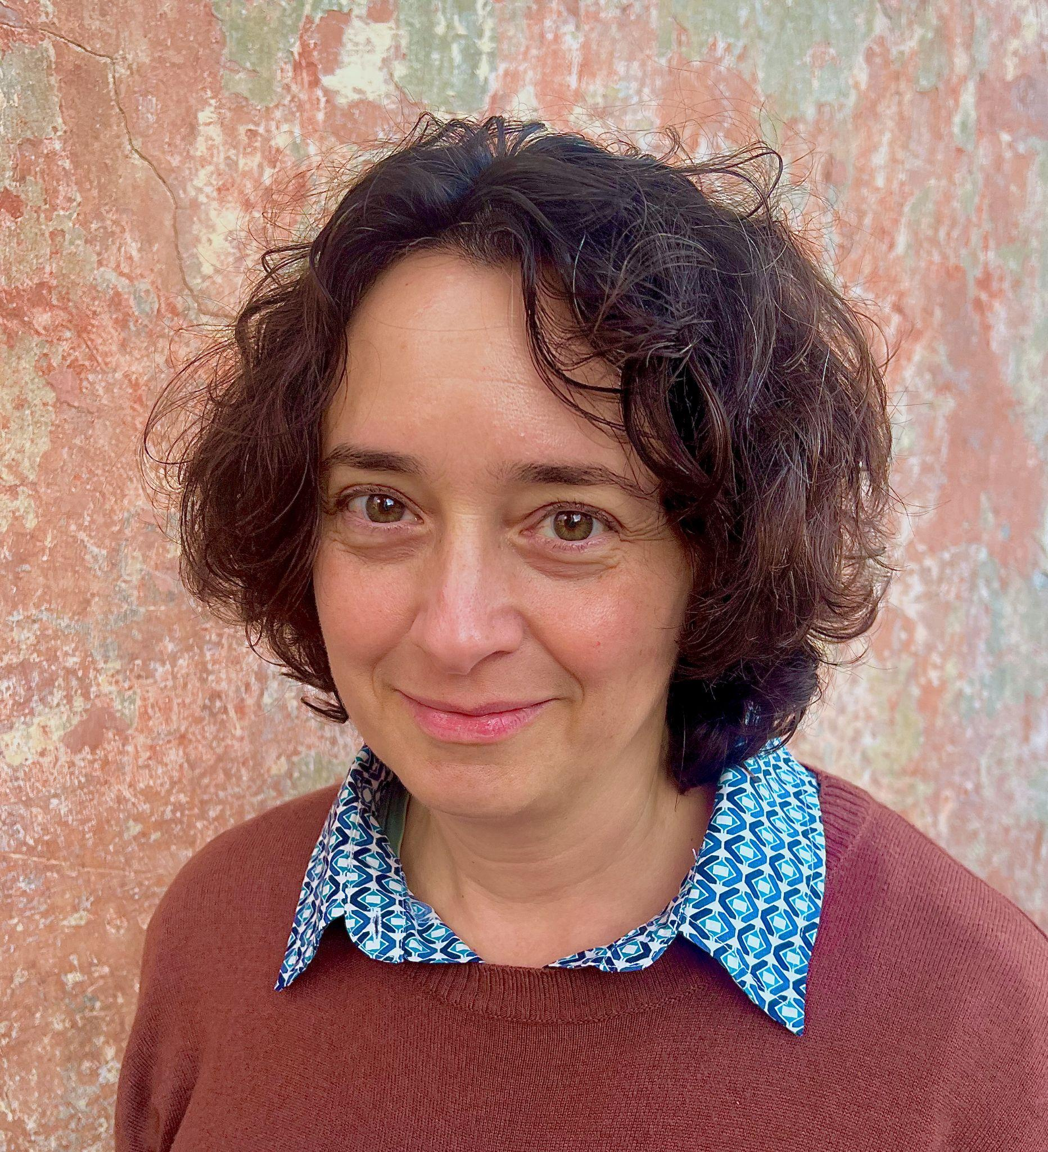
Kata Szili, PhD is a trainer in psychodynamic movement and dance therapy in Hungary. She has 23 years of experience leading psychodynamic movement and dance therapy groups. Her doctoral thesis investigates the contribution of modern psychoanalysis to body awareness work. Katalin is also a clinical psychologist and a psychotherapist. Besides Psychodynamic Movement Therapy (PMT) she is trined in analytically oriented psychotherapy, psychoanalysis, and hypnotherapy. She also teaches dance therapy at the university training of the HAMDT, and is one of the leaders of the Psychotherapist Training in Szeged.

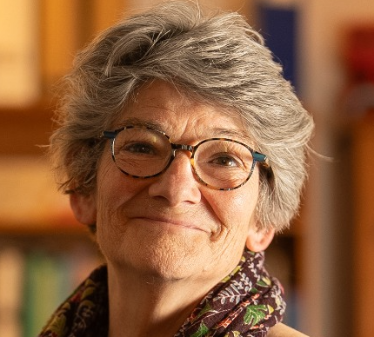
Susan Scarth - Senior Consultant is a Dance Movement Psychotherapist in Private Practice in Edinburgh, Scotland. She holds full membership with UKCP as a Registered DMP in the College of Humanistic and Integrative Psychotherapy. Susan is also registered with ISMETA as a Somatic Movement Therapist and Somatic Movement Educator (RSMT/E). She holds a Certificate in Movement Analysis (CMA) from Laban/Bartenieff Institute for Movement Studies in New York (LIMS NY). Susan supervised and lectured on the MA DMT programme at The Laban Centre London (now Trinity Laban, and held the role of Course Leader at Goldsmiths University of London, and subsequently at Queen Margaret University Edinburgh. She was one of the team that shaped and established the EADMT in 2010, taking on the role of President for 6 years and continuing her work with EADMT as Co-ordinator of the Training Standards Working Group. Susan now acts as Senior Consultant to the Training Standards Committee as she continues her work in the area of Training and professional development.

